

**Requirements Specification**

**Project Name: Vehicle Insurance Management System**

**Project ID: 1105**

**System Analysts: Tenti Morobe, Jubilant Motlhake,Kaelo Bokgatsu , Lindani Ngcobo, Siphamandla Mdango and Mpho Ledula**

Date: 26 May 2022

**Table of Contents**

**1** **INTRODUCTION 4**

1.1 Project Purpose 4

1.2 Project Scope and Product Features 4

1.3 Out of Scope 5

1.4 Project Acronyms, Abbreviations and Terms 5

1.5 Stakeholders 5

**2** **DESIGN REQUIREMENTS 6**

2.1 User Classes and Characteristics 6

2.2 Operating Environment (OE) 7

2.3 User / Training Documentation 7

2.4 Globalization / Localization Requirements (GR) 7

2.5 Assumptions (AS) 7

2.6 Dependencies (DE) 7

**USAGE SCENARIO(S) 8**

2.7 User Story 9

**3** **FUNCTIONAL REQUIREMENTS 11**

**4** **OTHER NONFUNCTIONAL REQUIREMENTS 12**

4.1 Security Requirements (SE) 12

4.2 Regulatory and Compliance Requirements (RE), (CP) 12

4.3 Other Data Storage, Archival, Back-up, Recover and Destruction (STR) 13

**5** **SYSTEM DIAGRAMS 13**

5.1 System Sequence Diagram (SSD) 13

5.2 Entity-relationship Model (ERD) 13

5.3 Data Flow Diagram (DFD) 13

**6** **GLOSSARY 14**

**7** **APPENDIX 14**

7.1 Reference 14

*7.1.1 14*

**Revision History**

| **Version** | **Date** | **Revision Description** |
| --- | --- | --- |
| .01 | 27/05/2022 | Draft Version |
| .02 |  |  |

1. **Introduction**

## Project Purpose

This is a Requirements Specification document for Liberty Finance's automobile insurance management system. Liberty Finance is a financial services and property investment firm. The new system will make it simple for managers to store client-insured vehicles. The technology will assist the company in being more successful, efficient, and data retrievable. The scope, aims, and goal of the new system are described in this document. This document also includes use cases, user stories, ERDs, System sequence diagrams, and DFD diagrams to model the functional requirements for the system.aph

## Project Scope and Product Features

The vehicle insurance management System will provide multiple online management functionality that handle data and information pertaining to vehicle insurance. The system will only have one main part, the web-based application management system.

Product Features:

The System will make use of the internet because it is web based and constantly need to be online to operate efficiently. All the information saved will be stored on the SQL database which is located on the Microsoft azure. The system does not allow for offline functionality.

The product features for the different parts of the system are as follows:

* **Secure Login and Logout**
* **Dashboard**
  + Display the summary of lists.
* **Categories Management**
  + Add New Category
  + List All Categories
  + View Category
  + Update Category
  + Delete Category
* **Insurance Policy Management**
  + Add New Insurance Policy
  + List All Insurance Policies
  + View Insurance Policy Details
  + Update Insurance Policy Details
  + Delete Insurance Policy Details
* **Client Management**
  + Add New Client
  + List All Clients
  + Update Client Details
  + View Client Details
  + List all Client's Insured Vehicles
  + Delete Client Details
* **Vehicle Insurance Management**
  + Add New Insurance
  + List All Insurances
  + Update Insurance Details
  + View Insurance Details
  + Print Insurance Details
  + Delete Insurance Details
* **Generate Reports**
  + Printable Date-wise Transaction Report
* **Manage User List (CRUD)**
* **Manage Account Details/Credentials**
* **Manage System Information**

## Out of Scope

* The cloud service provider will not change
* The cloud services and web address will not change
* The IT infrastructure will not change
* The project will affect web-based platforms only; all other platforms are out of scope

## Project Acronyms, Abbreviations and Terms

| **Term** | **Description** |
| --- | --- |
| ERD | Entity relationship diagram |
| DFD | Data Flow Diagram |
| SSD | System Sequence Diagram |
| UI | User Interface |

## Stakeholders

| **Name and Surname** | **Responsibility** | **Role** |
| --- | --- | --- |
| Neo Mponya | Project Owner | Facilitator |
| Nomathamsanqa Ntuli | Project Sponsor | Consultant |
|  |  |  |

1. **Design Requirements**

## User Classes and Characteristics

| **User Class Name** | **Critical (Y/N)** | **How They Use the System** |
| --- | --- | --- |
| Employee | Y | Use the system to view, delete, edit client information. |
| Use the system to view, delete, edit insurances. |
| Use the system to Use the system to view, delete, edit policies |
| Use the system to filter and print reports. |
| Use the system to Use the system to view, delete, edit category information. |
| Manage Admin account |
| Administrator | Y | Use the system to create new clients |
| Use the system to view, delete, edit client information. |
| Use the system to add new insurances |
| Use the system to use the system to view, delete, edit insurances |
| Use the system to add new policies |
| Use the system to use the system to view, delete, edit policies |
| Use the system to filter and print reports |
| Use the system to add new category |
| Use the system to Use the system to view, delete, edit category information. |
| Use the system to edit and delete user information. |
| Use the system to add a new user |
| Update system information |
| Manage Admin account |

## Operating Environment (OE)

|  |  |  |
| --- | --- | --- |
| **Number** | | **Requirement** |
| OE | 1 | The application will be deployed on the Microsoft Azure |

## User / Training Documentation

| **Name** | **Description and Format** |
| --- | --- |
| User Manual | The user manual describes how a user can use the system |

## Globalization / Localization Requirements (GR)

| **Number** | | **Requirement** |
| --- | --- | --- |
| GR | 1 | Local – English speakers |
| GR | 2 | Local – South African Market |

## Assumptions (AS)

| **Number** | | **Assumption** |
| --- | --- | --- |
| AS | 1 | The infrastructure is based in cloud computing |
| AS | 2 | The infrastructure uses Microsoft Azure |
| AS | 3 | Users are employees |

## Dependencies (DE)

| **Number** | | **Dependency** |
| --- | --- | --- |
| DE | 1 | Microsoft Azure platform |
| DE | 2 | SQL Database |

**Usage Scenario(s)**

*The following use case shows how users interacts with the system*





## User Story

*The following user story describes how the staff and administrator use the system*

|  |  |
| --- | --- |
| **Vehicle Insurance Management System** | **User Story (Staff)** |
| Dashboard | As a staff member, I can view the dashboard |
| Client List | As a staff member, I can view, edit and delete clients in the system |
| As a staff member, I can search for different clients in the system |
| As a staff member, I can view a list of clients in the system with a brief summary of each |
| Insurance list | As a staff member, I can search for different insurances in the system |
| As a staff member, I can view, edit and delete insurance files in the system |
| As a staff member, I can view the list of insurances with a brief summary of each. |
| Reports | As a staff member, I can print and filter reports based on the dates |
| As a staff member, I can view the list of all reports in the system with a brief summary of each |
| Category List | As a staff member, I can view, edit and delete categories |
| As a staff member, I can search for different categories in the system |
| As a staff member, I can view the list of all categories with a brief summary of each. |
| Policies List | As a staff member, I can view, edit and delete policies |
| As a staff member, I can search for different policies in the system |
| As a staff member, I can view the list of all categories with a brief summary of each. |
| Account manager | As a staff member, I can update my personal information and passwords |
| As a staff member, I can Log in and log out of the system |
| Navigation | As a staff member, I can select how many entities I want to display. |
| As a staff member, I can navigate between pages |

|  |  |
| --- | --- |
| **Vehicle Insurance Management System** | **User Story (Administrator)** |
| Dashboard | As an administrator, I can view the dashboard |
| Client List | As an administrator, I can add a new client |
| As an administrator, I can view, edit and delete clients in the system |
| As an administrator, I can search for different clients in the system |
| As an administrator, I can view a list of clients in the system with a brief summary of each |
| Insurances | As an administrator, I can add a new insurance in the system |
| As an administrator, I can search for different insurances in the system |
| As an administrator, I can add a new insurance in the system |
| As an administrator, I can view, edit and delete insurance files in the system |
| As an administrator, I can view the list of insurances with a brief summary of each. |
| Reports | As an administrator, I can print and filter reports based on the dates |
| As an administrator, I can view the list of all reports in the system with a brief summary of each |
| Category List | As an administrator, I can add a new category |
| As an administrator, I can view, edit and delete categories |
| As an administrator, I can search for different categories in the system |
| As an administrator, I can view the list of all categories with a brief summary of each. |
| Policies List | As an administrator, I can add a new policy in the system |
| As an administrator, I can view, edit and delete policies |
| As an administrator, I can search for different policies in the system |
| As an administrator, I can view the list of all categories with a brief summary of each. |
| User List | As an administrator, I can create a new user |
| As an administrator, I can view, update and delete the user’s information. |
| As an administrator, I can search for different users in the system. |
| As an administrator, I can view the list of all users in the system with a brief summary of each user. |
| Setting | As an administrator, I can update system information such as the system name, system cover, system logo and the system short name |
| Account manager | As an administrator, I can update my personal information and passwords |
| As an administrator, I can Log in and Log out of the system |
| Navigation | As an administrator, I can select how many entities do I want to display |
| As an administrator, I can navigate between pages |

1. **Functional Requirements**

|  |  |  |
| --- | --- | --- |
| **Functional Requirements** | **Functional Requirement Name** | **Requirement Description** |
| FR1 | Add new users | The system should allow for new users to be added |
| FR2 | Existing users’ information | Users' information should be able to be viewed, edited, and deleted through the system. |
| FR3 | Generate Reports | The system should allow for generation of date-wise transaction reports |
| FR4 | Add Insurances | The system should allow for addition of new insurances |
| FR5 | Insurance details | The system should allow for the viewing, editing, and deletion of insurance information. |
| FR6 | Add new policy | The system should allow addition of new policy |
| FR7 | Policy details | Viewing, updating, and deleting policy information should all be possible through the system. |
| FR8 | Search option | The system should provide a search function that allows users to look for information to which they have access. |
| FR9 | Manage Accounts | Users should be able to manage their accounts, including altering user information, passwords, usernames, and adding avatars. |
| FR10 | Add categories | The system should allow addition of new category |
| FR11 | Category details | Viewing, updating, and deleting category information should all be possible through the system. |
| FR12 | Navigation Pane | The system should allow for users to select the number of entries to display. |

1. **Other Nonfunctional Requirements**

## Security Requirements (SE)

| **Number** | | **Requirement** |
| --- | --- | --- |
| SE | 1 | The system must protect personal details |
| SE | 2 | The system must protect insurance information |
| SE | 3 | The system must protect policy information |
| SE | 4 | Secure log in/out |

## Regulatory and Compliance Requirements (RE), (CP)

| **Number** | | **Requirement** |
| --- | --- | --- |
| RE | 1 | Compliance of the POPI Act (Protection of personal information) |
| CP | 1 | Compliance of the Consumer Protection Act |

## Other Data Storage, Archival, Back-up, Recover and Destruction (STR)

| **Number** | | **Requirement** |
| --- | --- | --- |
| STR | 1 | Microsoft Services provides data storage and recovery |

1. **System Diagrams**

## System Sequence Diagram (SSD)

*The following diagram shows how the functions and use case functions are performed inside the system.*

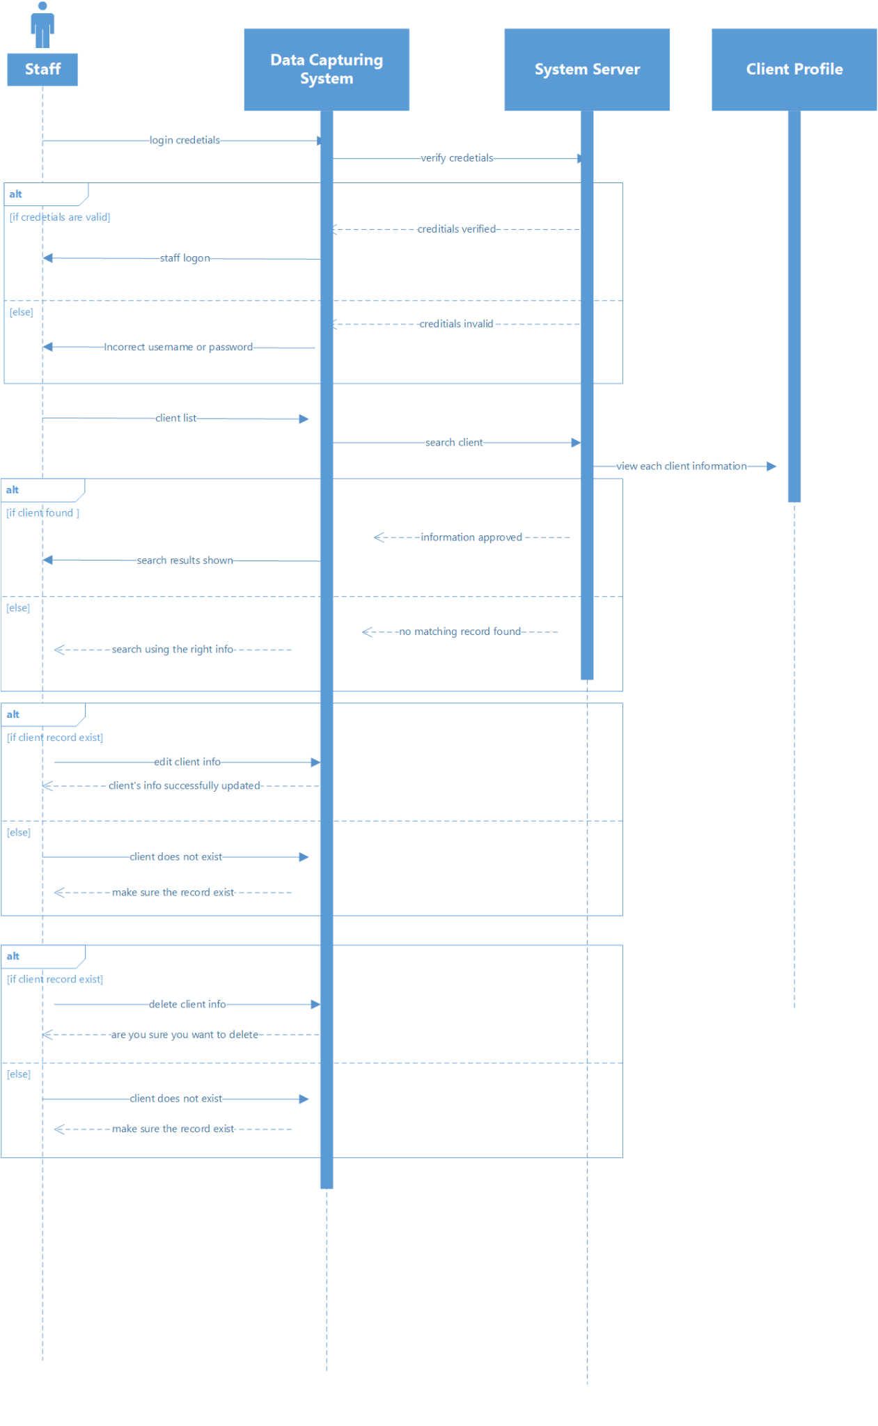

**

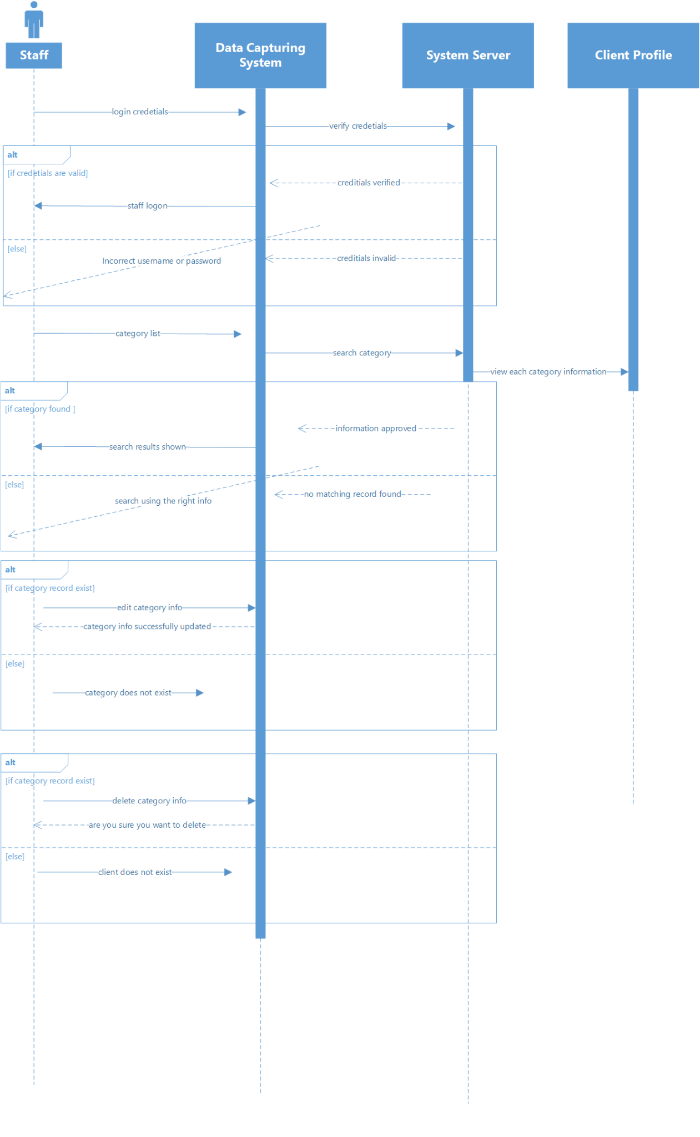

**

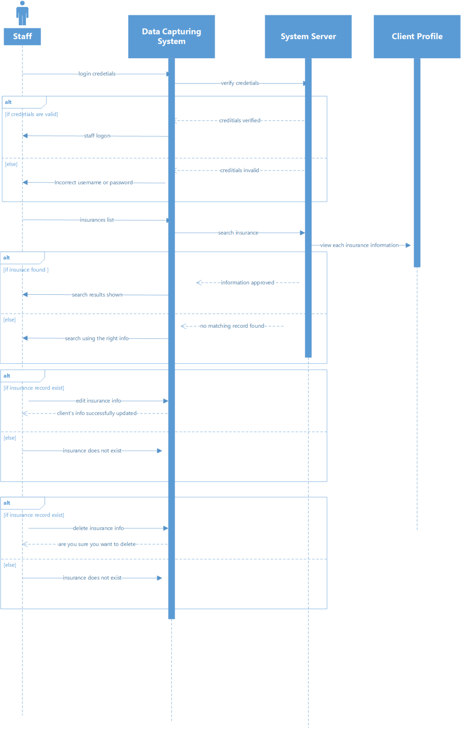

**

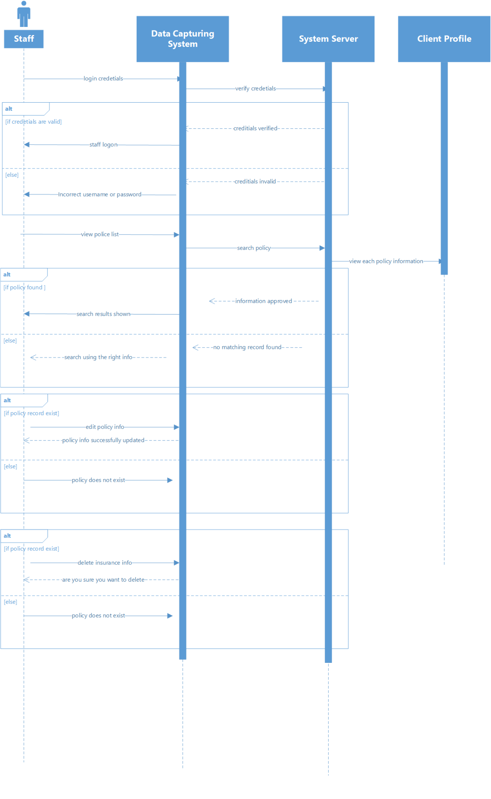

**

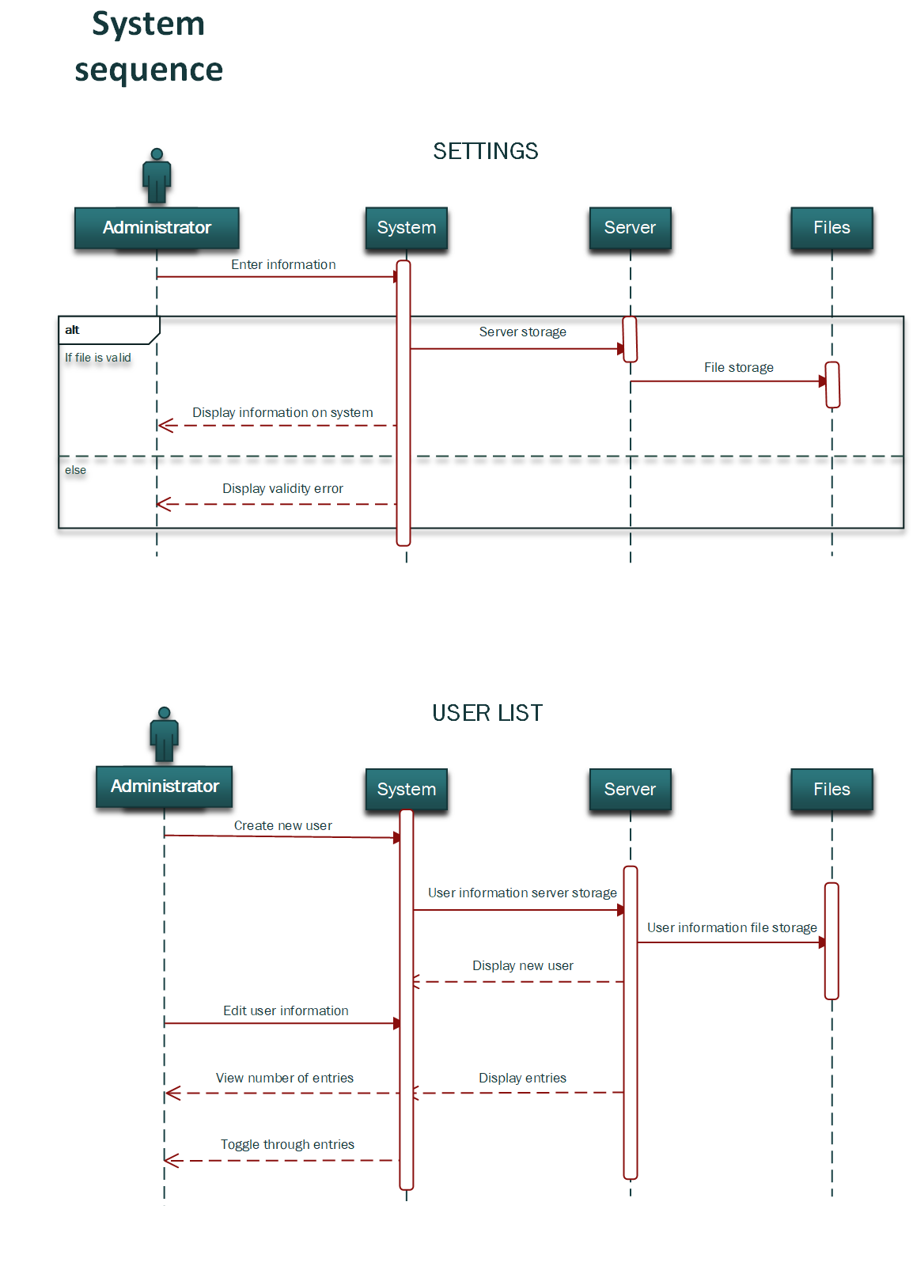

**

## Entity-relationship Model (ERD)

*The following diagram shows the relationship of entity sets in the database.*

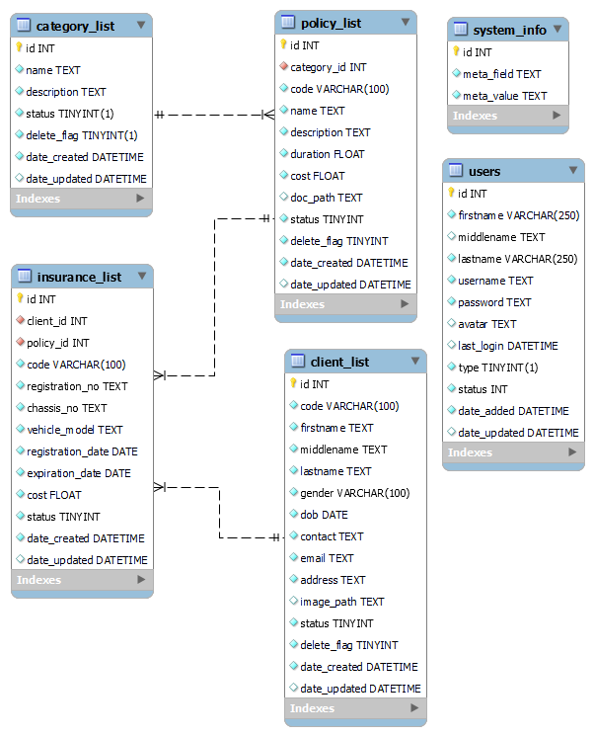

**

## Data Flow Diagram (DFD)

*The flow of data through the car insurance management system is illustrated in the diagram below.*

*The diagram is flow of data for the user ( Administrator)*

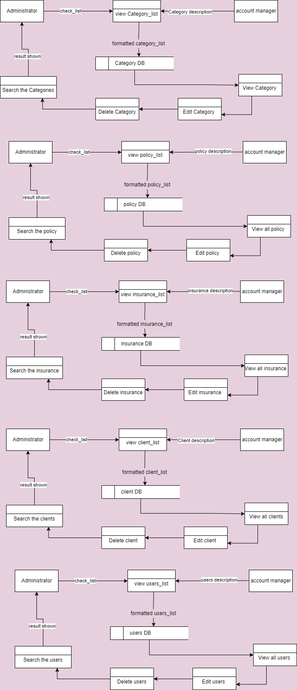

*The diagram is flow of data for the user ( Staff)*

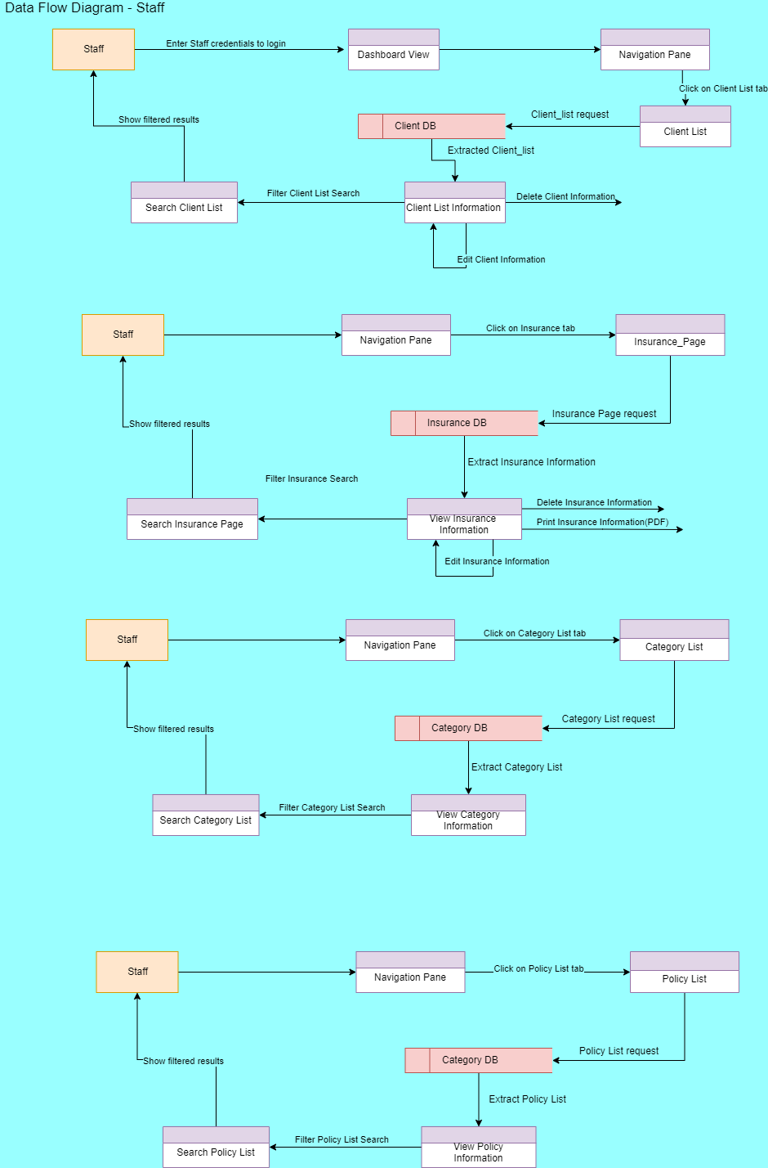

1. **Glossary**

| **Term** | **Definition** |
| --- | --- |
| **User** | A user is a person who utilise a computer or network services |
| **Administrator** | An administrator is in charge of maintaining, configuring, and ensuring the reliable operation of computer systems, servers, and data security measures. |
| **Client** | A client is a person or company who pays for a professional person or organization to provide them with a service. |
| **Insurance** | Insurance is a contract in which an individual or entity receives financial protection or compensation from an insurance provider in the event of a loss, which is represented by a policy. |
| **Policy** | A collection of ideas or a plan for dealing with specific conditions that has been publicly agreed to by a group of individuals, a commercial organization, the government, or a political party. |

1. **Appendix**

## Reference

|  |
| --- |
| Bandakkanavar, R. (2019, October 17). Software Requirements Specification document with example. Krazytech. <https://krazytech.com/projects/sample-software-requirements-specificationsrs-report-airline-database> |
| Editor. (2020, February 12). Non-functional Requirements: Examples, Types, How to Approach. AltexSoft. <https://www.altexsoft.com/blog/non-functional-requirements/> |
| A Guide to Functional Requirements (with Examples). (n.d.). Nuclino. Retrieved May 26, 2022, from <https://www.nuclino.com/articles/functional-requirements> |
| What is Data Flow Diagram (DFD)? How to Draw DFD?. Visual-Paradigm. Retrieved May 28, 2022 from  [What is Data Flow Diagram (DFD)? How to Draw DFD? (visual-paradigm.com)](https://www.visual-paradigm.com/tutorials/data-flow-diagram-dfd.jsp) |
| Microsoft. (n.d.). Create a UML use case diagram. Retrieved May 26, 2022, from  <https://support.microsoft.com/en-us/office/create-a-uml-use-case-diagram-92cc948d-fc74-466c-9457-e82d62ee1298> |
| R. (2020, July 28). Functional vs Non-Functional Requirements - Understand the Difference. ReQtest. <https://reqtest.com/requirements-blog/functional-vs-non-functional-requirements/> |